Practical No:-3
Arrays:-In Java, all arrays are dynamically allocated. (discussed below)
- Arrays are stored in contagious memory [consecutive memory locations].
- Since arrays are objects in Java, we can find their length using the object property length. This is different from C/C++, where we find length using sizeof.
- A Java array variable can also be declared like other variables with [] after the data type.
- The variables in the array are ordered, and each has an index beginning from 0.
- Java array can also be used as a static field, a local variable, or a method parameter.
- The size of an array must be specified by int or short value and not long.
- The direct superclass of an array type is Object.
- Every array type implements the interfaces Cloneable and java.io.Serializable.
- This storage of arrays helps us in randomly accessing the elements of an array [Support Random Access].
- The size of the array cannot be altered(once initialized). However, an array reference can be made to point to another array.
Code:-
import java.util.*;
public class arrays {
public static void main(String args[]){
int arr[] = {10,20,43,85,56,23};
for(int i=0;i<arr.length;i++){
System.out.print(arr[i]+" ");
}
System.out.print("\n");
}

}

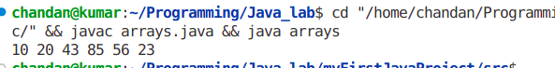
Output:-

2-D array
Code:-
import java.util.*;

public class arrays {
public static void main(String args[]) {
int arr[][] = { { 10, 20, 43 }, { 85, 65, 12 }, { 74, 25, 34 } };
for (int i = 0; i < 3; i++) {
for (int j = 0; j < 3; j++) {
System.out.print(arr[i][j] + " ");

}
System.out.print("\n");

}

}

}

Output:-
